Bahria University,

Karachi Campus



COURSE: SEL 310, WEB ENGINEERING

TERM: FALL 2022, CLASS: BSE- 5(B)

Submitted By:

**M Muaz Shahzad 02-131202-081**

(Name) (Reg. No.)

Submitted To:

**Engr. M. ADNAN UR REHMAN/Engr. M REHAN BAIG**

Signed Remarks: Score:

Bahria University,

Karachi Campus



LAB EXPERIMENT NO.

**02**

LIST OF TASKS

|  |  |
| --- | --- |
| TASK NO | OBJECTIVE |
| 1 | **Design multiple webpages including html & CSS. Include all the CSS properties of text, border**  **font etc. The following navigation tabs must be added:**  **1) Home (Give info about what your website is about)**  **2) Information (Include the detailed information related to the technology)**  **3) Gallery (Include images and Videos of technology)**  **4) About (Give the information about yourself)** |
| 2 | **Write a CSS rule that makes all text I .5 times larger than the base font ofthe system and colors the**  **text red.** |
| 3 | **Write a CSS rule that places a background image halfway down the page, tiling it horizontally.**  **The image should remain in place when the user scrolls up or down.** |
| 4 | **Write a CSS rule that gives all Ill and h2 elements a padding of 0.5 ems, a dashed border style and a**  **margin of 0.5 ems.** |
| 5 | **Add an embedded style sheet to the HTML5 document in the below figure. The style sheet should contain a rule that displays h1 elements in blue. In addition, create a rule that displays all links in blue without underlining them. When the mouse hovers over a link, change the link’s background color to yellow.** |

Submitted On

**11/10/2022**

**Task 01: Design multiple webpages including html & CSS. Include all the CSS properties of text, border**

**font etc. The following navigation tabs must be added:**

**1) Home (Give info about what your website is about)**

**2) Information (Include the detailed information related to the technology)**

**3) Gallery (Include images and Videos of technology)**

**4) About (Give the information about yourself)**

**Solution:**  Html code of this task as same as lab 1.  
  
**Style. CSS:**body{

    margin: 0px;

    background-image: url("https://encrypted-tbn0.gstatic.com/images?q=tbn:ANd9GcSRg_0jG33ShEMVfbTNe3r7yWUDxyrw__BGxg&usqp=CAU");

    background-repeat: no-repeat;

    background-size: cover;

    width: 100vw;

    height: 100%;

}

.navi{

    font-family: 'Times New Roman', Times, serif;

    font-weight: bold;

}

.image{

    border-radius: 6px 6px 6px 6px;

}

.fb{

   text-decoration: none;

   color: blue;

}

.Google{

    text-decoration:none;

    color: indigo;

}

.Insta{

    text-decoration:none;

    color: red;

}

.foot{

    display: flex;

    justify-content: center;

    font-size: larger;

}

.heading_blue{

    color: blue;

    font-size: larger;

}

.heading_indigo{

    color: indigo;

}

.btns{

    background-color: green;

    border-color: green;

    border-radius: 6px 6px 6px 6px;

    color: white;

}

.btnc{

    background-color: red;

    border-color: red;

    border-radius: 6px 6px 6px 6px;

    color: white;

}

**Output:**

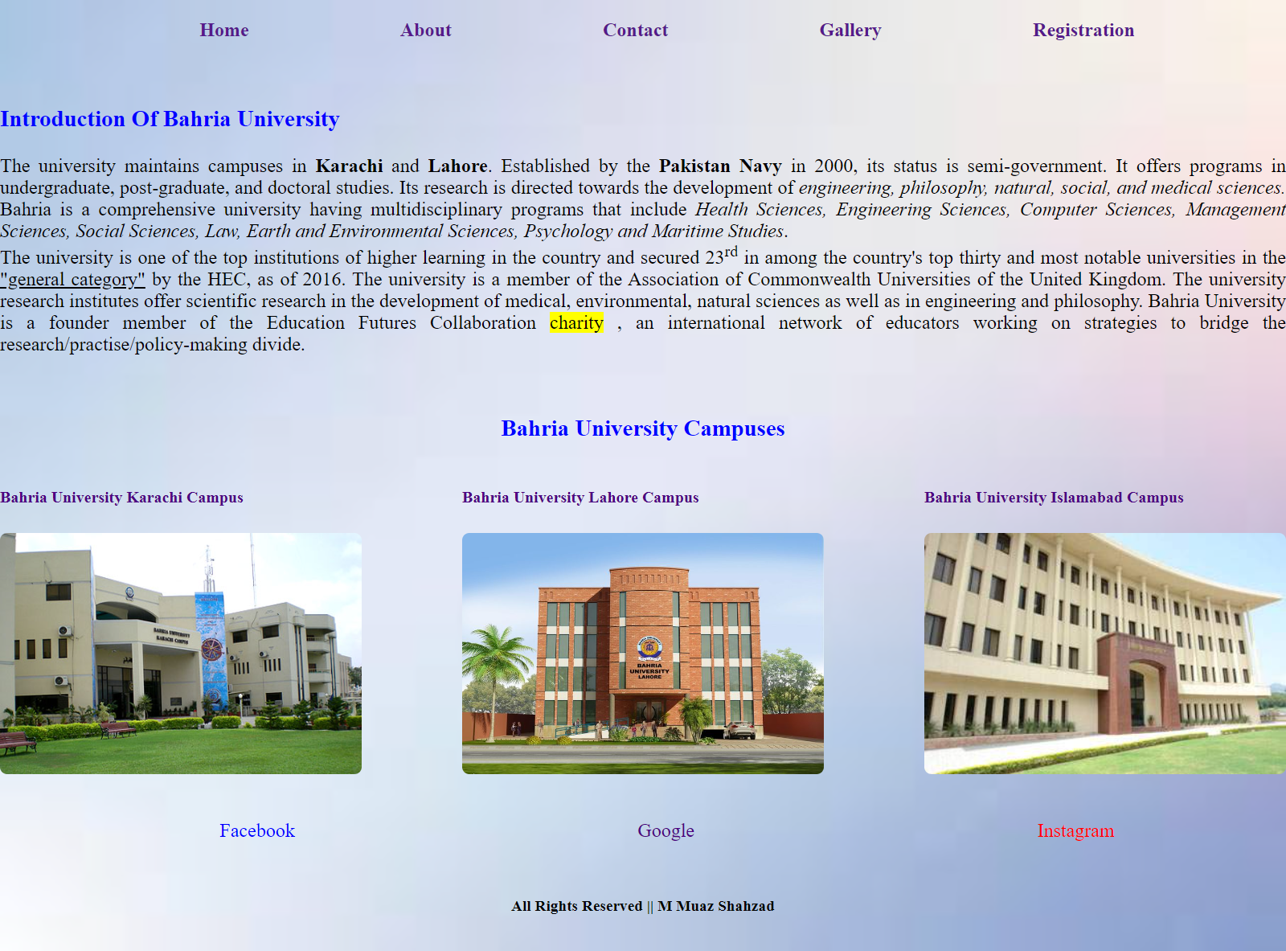

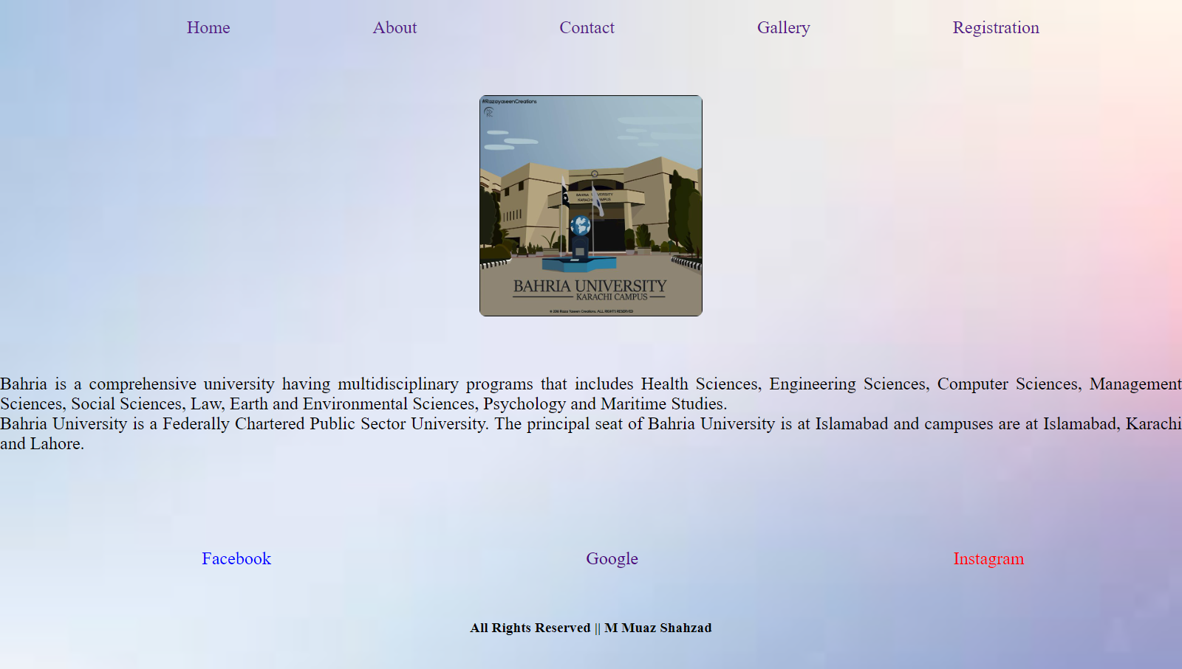

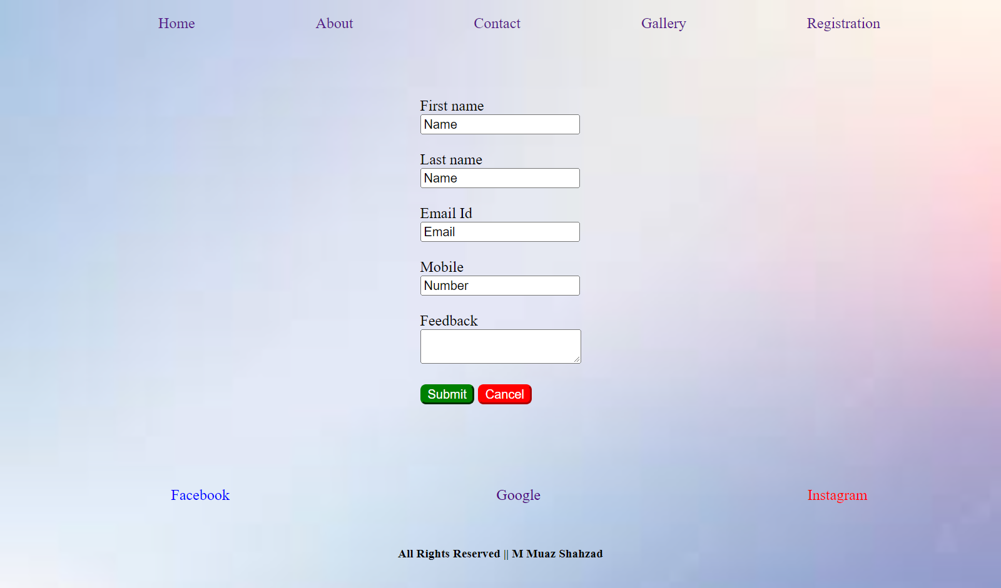

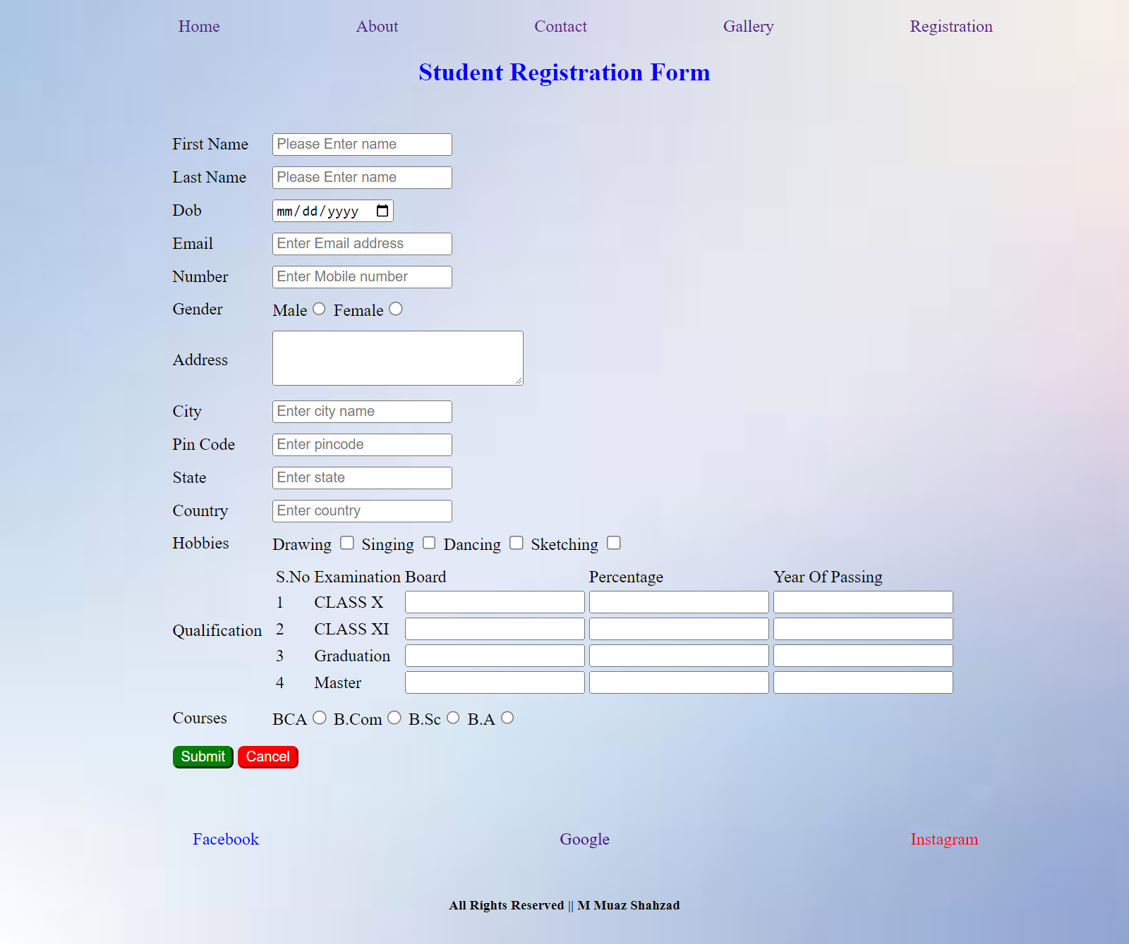

**Task 02: Write a CSS rule that makes all text I .5 times larger than the base font of the system and colors the text red.**

**Task 03: Write a CSS rule that places a background image halfway down the page, tiling it horizontally.**

**The image should remain in place when the user scrolls up or down.**

**Task 04: Write a CSS rule that gives all Ill and h2 elements a padding of 0.5 ems, a dashed border style and a margin of 0.5 ems.**

**Task 05: Add an embedded style sheet to the HTML5 document in the below figure. The style sheet should contain a rule that displays h1 elements in blue. In addition, create a rule that displays all links in blue without underlining them. When the mouse hovers over a link, change the link’s background color to yellow.**

**Solution:**<!DOCTYPE html>

<html lang="en">

<head>

    <meta charset="UTF-8">

    <meta name="viewport" content="width=device-width, initial-scale=1.0">

    <link rel="stylesheet" href="Style.css">

    <link rel="stylesheet" href="Css/Contact.css">

    <title>Web Engineering</title>

</head>

<body>

  <header>  
        <nav>  
            <ul class="navi" style="list-style: none;display: flex;justify-content: space-evenly;">  
                <a href="Lab1.html" style="text-decoration:none">  
                    <li>Exercise 1</li>  
                </a>  
                <a href="#Ex2" style="text-decoration:none">  
                    <li>Exercise 2</li>  
                </a>  
                <a href="#Ex3" style="text-decoration:none">  
                    <li>Exercise 3</li>  
                </a>  
                <a href="#Ex4" style="text-decoration:none">  
                    <li>Exercise 4</li>  
                </a>  
                <a href="#Ex5" style="text-decoration:none">  
        <li>Exercise 5</li>  
                </a>  
            </ul>

        </nav>

  </header>

    <!--  -->

    <!-- Main Body -->

    <br>

    <br>

    <br>

    <br>

    <section>

        <div>

            <h4 class="heading_indigo" style="display: flex;justify-content: center;margin: auto;font-size: larger;">

                Exercise 2

            </h4>

            <div style="width: 50%;display: flex;justify-content: center;margin: auto;">

                <p style="text-align: justify;">

                    Lorem ipsum dolor sit amet consectetur adipisicing elit. Esse minus nam, cumque adipisci, officia ab

                    aut

                    perspiciatis quos aspernatur est totam mollitia accusantium provident, quisquam odit quod error

                    fugit

                    dolorum?

                </p>

            </div>

        </div>

    </section>

    <section>

        <hr>

        <div class="ex4">

            <h1 class="heading_indigo" style="display: flex;justify-content: center;margin: auto;font-size: larger;">

                Exercise 4

                <br>  
                [Adding padding And Margin]

            </h1>

            <h2 style="color: blue;">

                Lorem ipsum dolor sit amet

            </h2>

        </div>

        <hr>

    </section>

    <section>

        <div>

            <h3 class="heading_indigo" style="display: flex;justify-content: center;margin: auto;font-size: larger;">

                Exercise 5</h3>

            <div style="display: flex;justify-content: center;margin: auto">

                <h1 class="ex5">Here Are My Favourite Site</h1>

            </div>

            <div  style="display: flex;justify-content: center;margin: auto">

                <ul>

                    <li><a href="#">Twitter</a></li>

                    <li><a href="#">Facebook</a></li>

                    <li><a href="#">Google</a></li>

                </ul>

            </div>

        </div>  
    </section>  
    <br>  
    <br>  
    <br>  
    <!-- Footer Of Website -->  
    <section id="Ex5">  
        <footer>

            <ul style="list-style: none;display: flex;justify-content: space-around;">

                <li>

                    <a class="fb" href="">Facebook</a>

                </li>

                <li><a class="Google" href="">Google</a></li>

                <li><a class="Insta" href="">Instagram</a></li>

            </ul>

            <div class="foot">

                <h6>All Rights Reserved || M Muaz Shahzad</h6>

            </div>

        </footer>

    </section>

</body>

</html>

**Output:  
